Chapter 13, Problem 16.

Obtain the Norton equivalent at terminals a-b of the circuit in Fig. 13.85.

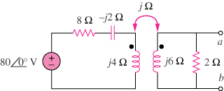

Figure 13.85
For Prob. 13.16.

